**NATURE QUIZ**

**WINTER**

1. The weather in winter is _ _ _ _ and we have _ _ _ _.
2. F_ _ _ _ _ _ and _ _ _ _ _ don´t grow.
3. _ _ _ _ _ _ _ sleep or fly to Africa:

-.......................................................................... are in the house or outside.

- ............................... fly to Africa.

-....................................................... sleep.

1. We can 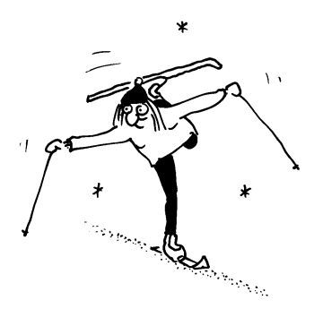 _ _ _, 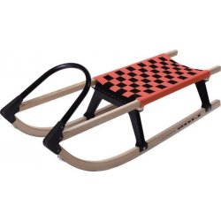 _ _ _ _ _ and _ _ _ _ a _ _ _ _ _ _ _ .
2. We wear _ _ _ _ c_ _ _ _ _ _ for example: ...............................................................
3. We have Ch_ _ _ _ _ _ _ in winter. We 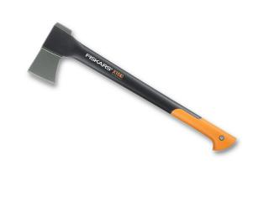 _ _ _ or _ _ _ trees.

**SPRING**

1. In spring flowers and trees _ _ _ _.
2. Animals 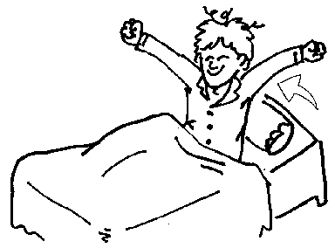 _ _ _ _ _ _ and birds come back from _ _ _ _ _ _.
3. _ _ _ _ _ _ _ _ _ _ _ are born, for example chicken, lambs, ducks.
4. We can plant ......................................................................................in the gardens.
5. The weather is warm, the  _ _ _ shines but it is cold.
6. White spring flower is _ _ _ _ _ _ _ _.

NAME: .....................................................................

.....................................................................